**Quantifying surface water-groundwater exchange using temperature profile inverse modelling at a riparian wetland**

Jack Lange

Submitted under the supervision of Crystal Ng to the University Honors Program at the University of Minnesota-Twin Cities in partial fulfillment of the requirements for the degree of Bachelor Science, *summa cum laude* in Earth Sciences.

May 2018

**Acknowledgments**

I would like to thank Crystal Ng for her guidance throughout this work. Field work, camaraderie, and support were provided by Amanda Yourd, Patrick O’Hara, Harsh Anurag, Lelia Saberi, Aubrey Dunshee and the rest of the U of MN computational hydrogeology group throughout this project. I would also like to thank the Evans Scholar foundation for their financial support which made this research possible. Finally, I would like to thank my family for their love and support over the last 2 years.

**Abstract**

Second Creek is manoomin (wild rice) stream located on the Iron Range in northeast Minnesota that has been impacted by mining pollution. In order to understand how mining-derived sulfate affects biogeochemical cycling at Second Creek, surface water-ground water exchange must be quantified because it controls geochemical gradients in the sediment. We employed inverse temperature profile modeling to estimate hyporheic flux at the site. Temperature profile methods have been most widely applied in streambeds with sediments that are sand-size and greater, and support relatively high flux magnitudes. In contrast, the Second Creek study site is a riparian wetland where low hyporheic flux is expected. Streambed temperature profiles were measured at three locations across a transect of the site spanning from the main stream channel to the flanking wetland area over the summer of 2016.  The data were collected using low-cost, open-source vertical temperature profilers and “ALog” data loggers. The USGS model 1DTempPro was applied to the temperature data, along with co-located head data at each location to estimate hydraulic conductivity across the transect. The sediment thermal parameters used in the model were constrained based on the sediment bulk density, which is strongly controlled by soil organic content. The estimated hydraulic conductivity values were applied to the measured head gradients to generate time series of hyporheic flux at the transect for the summer. Results showed spatial variability in both hydraulic properties and hyporheic flux. Across the transect, flux was upward toward the surface water for nearly the entire summer, though the magnitude of the flux varied dynamically in response to variable weather conditions and one flux reversal occurred following a strong late-summer storm event.

**Table of Contents**

**Introduction**

**Study Site**

**Methods**

**Inverse temperature profile modelling**

**Data collection**

**Model input parameter estimation**

**Results and Conclusions**

**Sensitivity Analysis**

**Dispersivity**

**Thermal conductivity**

**Saturated heat capacity**

**Outro**

**Introduction**

The impact of mining on water quality in Minnesota’s iron range is a contentious topic. Elevated sulfate concentrations are present in the lakes and streams of the area due to runoff from mining operations (Ng et al., 2017 (a)). Concern that elevated sulfate levels in the surface water would negatively impact manoomin (wild rice) growth has prompted in depth studies of geochemical processes in aquatic ecosystems (Pastor el al., 2017; Myrbo et al., 2013; Ng et al., 2017 (a); Yourd 2017).

The work in this study is a continuation of the work done of (Yourd, 2017) and (Ng et al. 2017, (a) ), who investigated the effect of hydrologic conditions on sulfur cycling in stream sediment. Their study focused on a stream called Second Creek which is located in northeastern Minnesota on the iron range. More information on the study site is presented in the Study Site section.

This study addresses the need identified in (Yourd, 2017) for a reliable constraint on hydrologic flux at the Second Creek site. This constraint is necessary because the geochemical gradient in the hyporheic zone where manoomin is rooted is controlled by hydrologic flux (Hayashi & Rosenberry 2002; Kurtz et al. 2007). The inverse temperature profile modelling technique was employed using data collected in the summer of 2016 to better constrain the hyporheic flux at the site.

**Study Site**

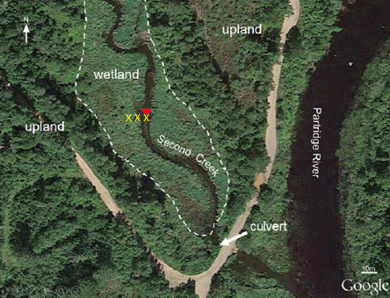

Figure 1: Second Creek Study Site. Yellow X’s indicate the location of each temperature probe and collocated piezometer. From west to east, each location is referred to as the west wetland, west streambed, and the center streambed.

The second creek site is a riparian wetland, the main stream channel is 2-3 meters wide and surrounded by 20-30 meters of wetland. The main channel is 1-2 meters deep. The site is underlain by glacial outwash and till. At the surface the sediment is extremely heterogeneous and has a high fraction of organic matter. Sources of surface water to the stream include mining tailings basins which causes elevated sulfate levels in the channel. During the summer months, manoomin and submergent macrophytes grow in the main channel of the stream, and the densely vegetated wetlands contain grasses, sedges, and shrubs. (Yourd, 2017) The site was previously studied during a statewide survey on the impacts of elevated sulfate concentration on manoomin. (Myrbo, 2013).

**Methods**

The quantity of interest in this study is vertical hydrologic flux in the streambed of Second Creek. Hydrologic flux through porous medium is described by Darcy’s law, presented here:

(1)

is the vertical hydrologic flux. is the hydraulic conductivity, which describes the medium’s ability to let water flow through. is the gradient of head between the aquifer and the surface water. In hydrologic studies the head gradient is can be measured in the field so the main challenge is quantifying the hydraulic conductivity. Hydraulic conductivity is an extremely variable quantity. It can range over many orders of magnitude for a single medium. Inverse temperature profile modelling will help to constrain K so that the hydrologic flux can be calculated.

**Inverse Temperature Profile Modelling**

The inverse temperature profile method uses temperature as a tracer to infer movement of water through an aquifer - surface water interface. At the Second Creek site the surface water temperature fluctuates diurnally as it is heated by the sun and subsequently cools overnight. The surface water temperature fluctuation propagates down into the hypothetic zone where the surface water comes into contact with groundwater. The mixing of surfaces and groundwater in the streambed damps out the diurnal temperature signal. In addition to signal attenuation, the 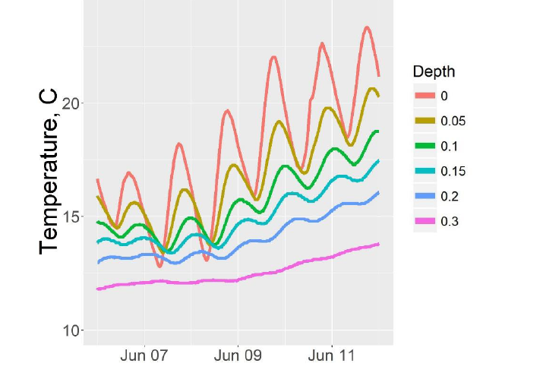signal is also shifted in time. This phenomenon is demonstrated in figure 2.

Figure 2: Sample streambed temperature profile from Second Creek. Surface water exhibits the strongest diurnal fluctuations. The diurnal fluctuations are almost entirely damped out at 0.3 m depth. The diurnal signal is also phase shifted at depth.

The magnitude of signal attenuation that occurs is related to the direction of water flow in the streambed. In a gaining stream, the signal will damp out a more shallow depth than in a losing stream where infiltrating surface water carries the temperature signal with it. The phase lag at depth is controlled by the time which the signal takes to propagate, which is in turn dictated by hydrologic flux.

One dimensional propagation of heat through a is well understood and described by the heat diffusion equation

(2)

The meaning of each variables in this equation is listed in Appendix 1.

Using the top and bottom of an observed temperature profile as boundary conditions, if the hydrologic and thermal parameters are known, then a synthetic temperature profile can be generate using forwards differences. 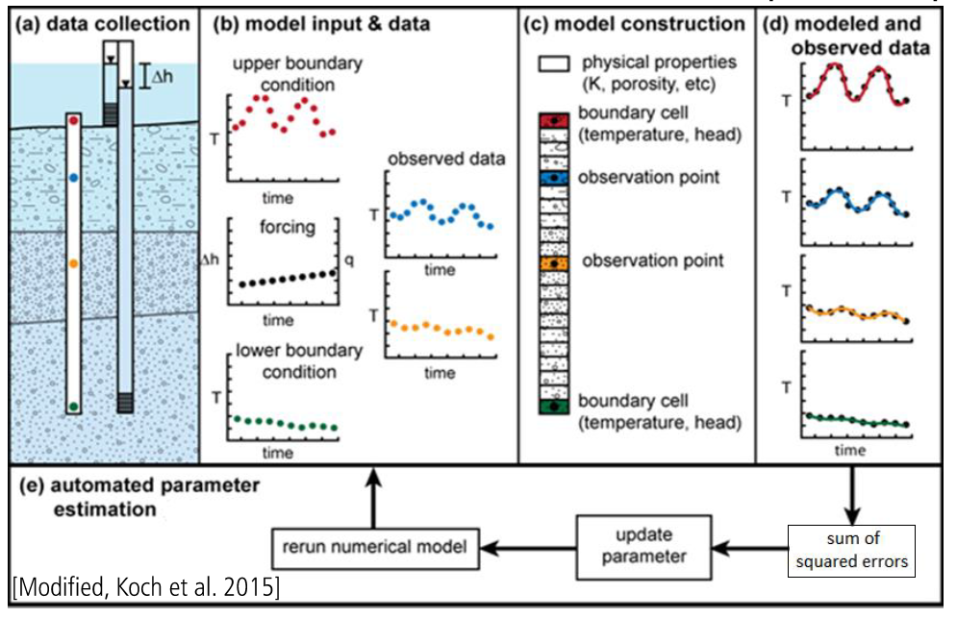

Work this in with some more elaboration on the inverse modelling process

Comparison between synthetic temperature profiles and observed profiles can be used to estimate the parameters of the diffusion equation. The USGS GUI 1DTempPro allows users to calibrate the parameters of the heat diffusion equation using an observed profile and some known parameters. (Koch et al., 2015). The program can perform automated parameter estimation for one parameter if it is provided with the rest of the parameters. More information on 1DTempPro is available in (Koch et al., 2015).

1DTempPro was used to estimate hydraulic conductivity at each temperature probe. For this mode of operation the model requires a temperature profile, a time series of the head difference between the surface water and groundwater, scaled to the length of the temperature probe and the physical and thermal properties of the sediment.

**Data Collection**

To inform the inverse model, temperature and head data was collected during the summer of 2016. The temperature probes were 1 inch PVC tubing with 6 thermistors attached. The probes were inserted into the stream or wetland sediment such that the top thermistor was approximately at the sediment-water interface, and the bottom thermistor was located at approximately 30-40cm depth below the sediment-water interface, with most sensors clustered within the top 10 cm, which corresponds to the manoomin root zone. (Yourd, 2017). Temperature readings were logged at 10 to 15 minute intervals to capture diurnal and seasonal temperature variability at the site. Two probes collected data from June to August and one collected data from June to October. The location of the probes is indicated in figure ().

Head data was collected using three piezometers and a stream gauge. The piezometers and temperature probes were collocated. Pressure transducers in each piezometer and the stream gauge collected pressure data for the entire summer. The data loggers used in this study were low cost, open source loggers developed by Northern Widget LLC. (Wickert, 2014)

One gap in the stream gauge data exists from 7/25/16 to 8/1/16. The stream gauge went dry during this period. The gauge was relocated in the stream channel during field work on 8/1/2016.

The elevation of the top of casing for the transducers and stream gauge were surveyed 10/1/16. The depth to each transducer was also measured.

Atmospheric pressure data was provided by \_\_\_\_\_\_\_ (Crystal, who provided this data, I recall that it was a state of MN study?) Site precipitation data was acquired from the nearest weather station located in Embarrass, MN 10 miles north of the site.

The atmospheric pressure was subtracted from the pressure readings made in each piezometer and the stream gauge. The elevation of each transducer was calculated from the surveyed elevation and measured depth for each transducer. The elevation of each transducer was used to convert the pressure measurements into hydraulic head measurements based on a consistent datum across all of the piezometers.

The elevation of the stream gauge before it was moved on 8/1/16 was not surveyed so a correction factor was applied to the data from the first half of summer. The correction factor was determined by imposing the assumption that the average head difference between each

Explain what delta h is

piezometer and the stream gauge was constant throughout the summer. This was accomplished by shifting the 6/1 – 7/25 portion of each *Δh* time series by the difference between the average *Δh* for 8/1- 10/1 and average *Δh* for 6/1 – 7/25. *Δh* is the difference in head between a piezometer and the stream gauge.

**Model input parameter estimation**

To complete the forward modelling, 1DTempPro requires information about the physical properties of the streambed. Specifically, porosity, the thermal conductivity of the sediment and the sediment’s saturated heat capacity. The streambed is composed of a mixture of siliclastic sediments and organic matter. The sediment at Second Creek is extremely heterogeneous, as show in figure 3.

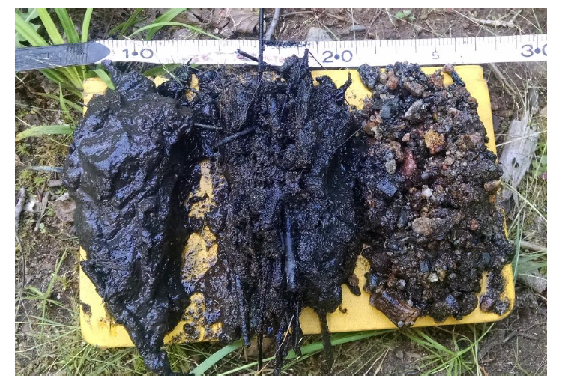

Figure 3: Second Creek wetland sediment (left) and streambed sediment (center, right).

(Yourd, 2017)

In order to make a reasonable estimation of the thermal parameters of the site sediment some simplifying assumptions were required. The first simplifying assumption was that the sediment was composed entirely of two endmembers, siliclastic sediment and soil organic matter. The second simplifying assumption is that the streambed is homogenous across all of the temperature probe locations. Both of these assumptions are be justified during model sensitivity analysis in the results and conclusions section.

The percentage, by mass, of soil organic matter and siliclastic minerals present in the sediment was calculated using the following expressions

The value for dry bulk density () was established in (Myrbo, 2013). The values for and were sourced from (Farouki, 1986). This calculation resulted in a sediment makeup of 90% SOM and 10% siliclastic material. High organic content is expected at Second creek, and this value is supported by the images above where many of the sediment samples appear to contain entirely SOM. In order to extend to our second assumption (heterogeneity) an 80% SOM - 20% silictastic split was determined to better generalize the conditions at the site.

Using the fraction of SOM and siliclastic, the thermal properties of the streambed can be estimated by the following methods from (Farouki, 1986).

Sediment Thermal conductivity,

Saturated heat capacity,

This method bounds the thermal parameter with an upper and lower limit. Values for,, and were found in Farouki (1986). Validity of the resulting parameter range is discussed in the sensitivity analysis portion of the results and conclusions section.

-present the range

The last parameter needed for the forwards model is dispersivity. This parameter depends on the scale of the problem. A range of dispersivity values were values were considered based on (Zheng & Bennet, 2002). The validity of the range is analyzed in the sensitivity analysis portion of the results and conclusions section.

**Results and Conclusions**

The estimates of hydraulic conductivity at each temperature probe were obtained using 1DTempPro. They are presented in Table 1. The user specified parameter values for these estimations are presented in table 2. The validity of the estimated hydraulic conductivity values is explored in the sensitivity analysis section.

|  |  |
| --- | --- |
| **Location** | **Hydraulic conductivity, m/d** |
| West wetland | 0.07 |
| Stream west | 0.04 |
| Stream center | 0.18 |

|  |  |
| --- | --- |
| **Parameter** | **Value** |
| θ | 0.51 |
|  | 0.56 w/(m C) |
|  | 2.44\*10^6 J/(m3 C) |
| α | 0.1 m |

Table 2: 1DTempPro inverse model inputs for hydraulic conductivity estimation.

Table 1: Hydraulic conductivity estimates from the 1DTempPro inverse model. Mode inputs include head and temperature time series, and the parameter values in table 2.

These hydraulic conductivity values were plugged in to Darcy’s law with the head gradient time series at each probe to generate a time series of vertical hydrologic flux at each temp probe. The hydrologic flux time series are presented in figure (). The time series are plotted with precipitation data from the Embarrass, Mn weather station to help visualize the relationship between precipitation and hydrologic flux

C:\SecondCreekGit\Presentations and figures\North Central GSA poster\q_smoothed.tif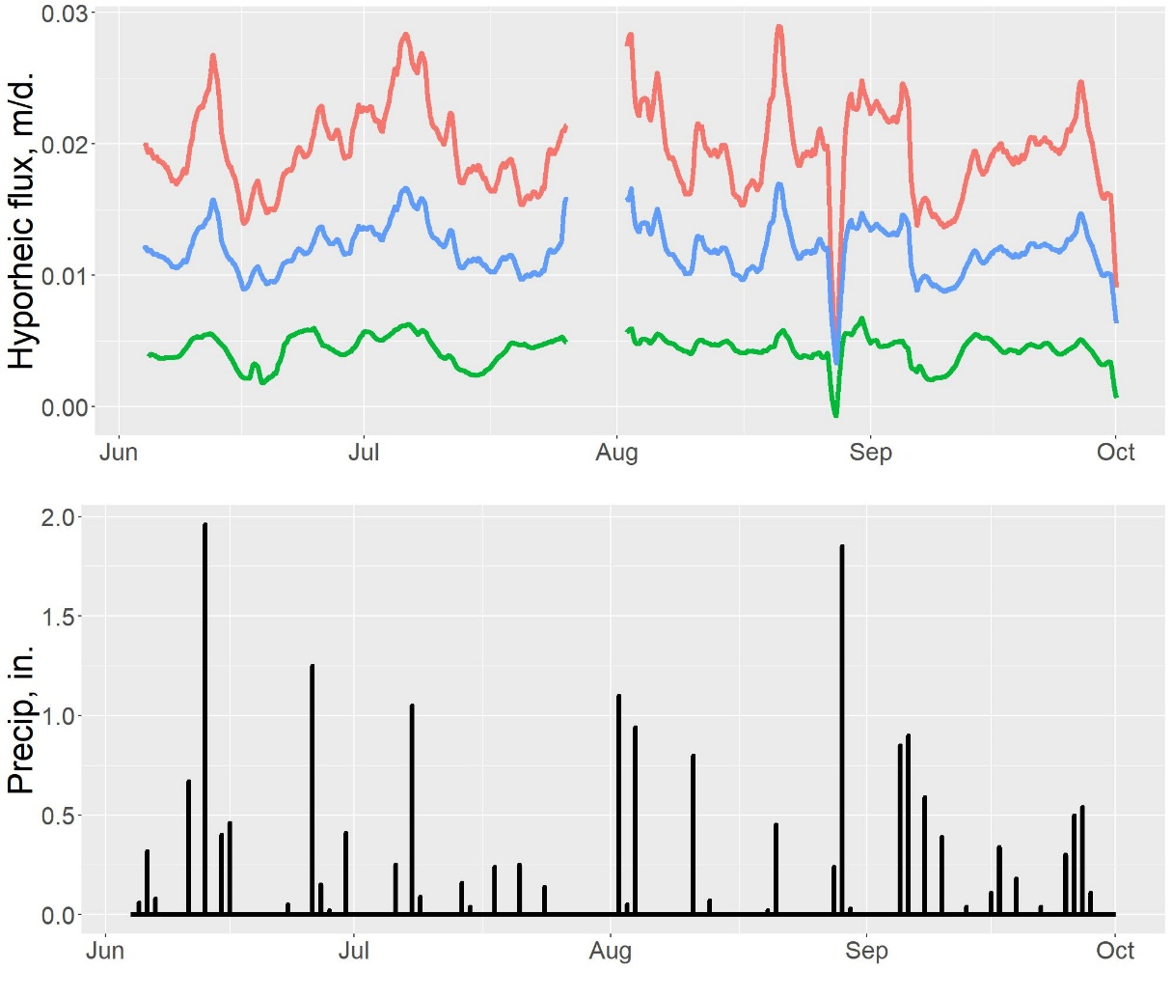

Figure 3: Vertical hyporheic flux and precipitation at Second Creek for summer 2016. Positive values indicate upwards flux. Large storm events appear to control hydrologic flux at the site, though the exact mechanism is uncertain.

The highest hydraulic conductivity and flux occur in the west wetland, followed by the stream center and the west stream channel. This is counterintuitive, as we originally expected the wetland area to have the smallest flux. There are several possible explanations for this discrepancy. First, the site sediment is highly heterogeneous which suggests that the hydrologic flux is equally heterogeneous. It is possible that the wetland temperature probe was placed in a region that facilitated higher flux while the stream probes were located in lower flux regions. Another possible explanation is that flow at the wetland probe has a significant horizontal component, violating the assumption of 1DTempPro that hydrologic flux is entirely in the vertical direction. This explanation has merit because the head in the wetland sediment was consistently higher than the head at the base of the stream which suggests that the water in the wetland sediment could have a significant component of flow velocity towards the stream.

The direction of vertical flux across the transect is upwards for the entire summer except for one brief flux reversal in late August. The magnitude of vertical hydrologic flux over the summer is variable. The flux magnitude appears to be linked with precipitation. Major changes in flux magnitude occur following large rain events. Sometimes these rain events increase the upward flux magnitude, indicating that the rainfall initiates a base flow event. In other cases, rain events are followed by decreased upwards flux, or even downwards flux, indicating that the rainfall runs off into the surface water quickly. A possible explanation for this discrepancy is that the precipitation data was collected from a weather station that is 10 miles north of the study site, so it is possible that during these storm events the stream and the weather station don’t experience the same meteorological conditions. The streams response to the storms could be related to the proximity of the storm to the stream. For example, a distant storm would be more likely to trigger a large prolonged base flow event, and a storm that occurs near second creek could cause a rapid rise in surface water levels, resulting in an immediate decrease in upwards flux or even downwards flux. Another possible explanation for the varied response to storm events could be seasonal changes in vegetation in the region. More study is required to determine which of these explanations have merit.

**Sensitivity analysis**

This section is dedicated to evaluating the quality of the model results and the model’s dependency on the hand estimated thermal parameters. To investigate this, the inverse model was run over the possible range of parameters estimated earlier for dispersivity, thermal conductivity, and heat capacity. The inverse model was run as each parameter was varied over its range, while the rest of the parameters were held at the values in table 2. The resulting value of K for each of these model runs is presented in figure 4. The goodness of fit between the model’s final synthetic profile and the observed temperature profile is qualitatively demonstrated by the size of each point in figure 4.

C:\SecondCreekGit\Presentations and figures\North Central GSA poster\q_smoothed.tif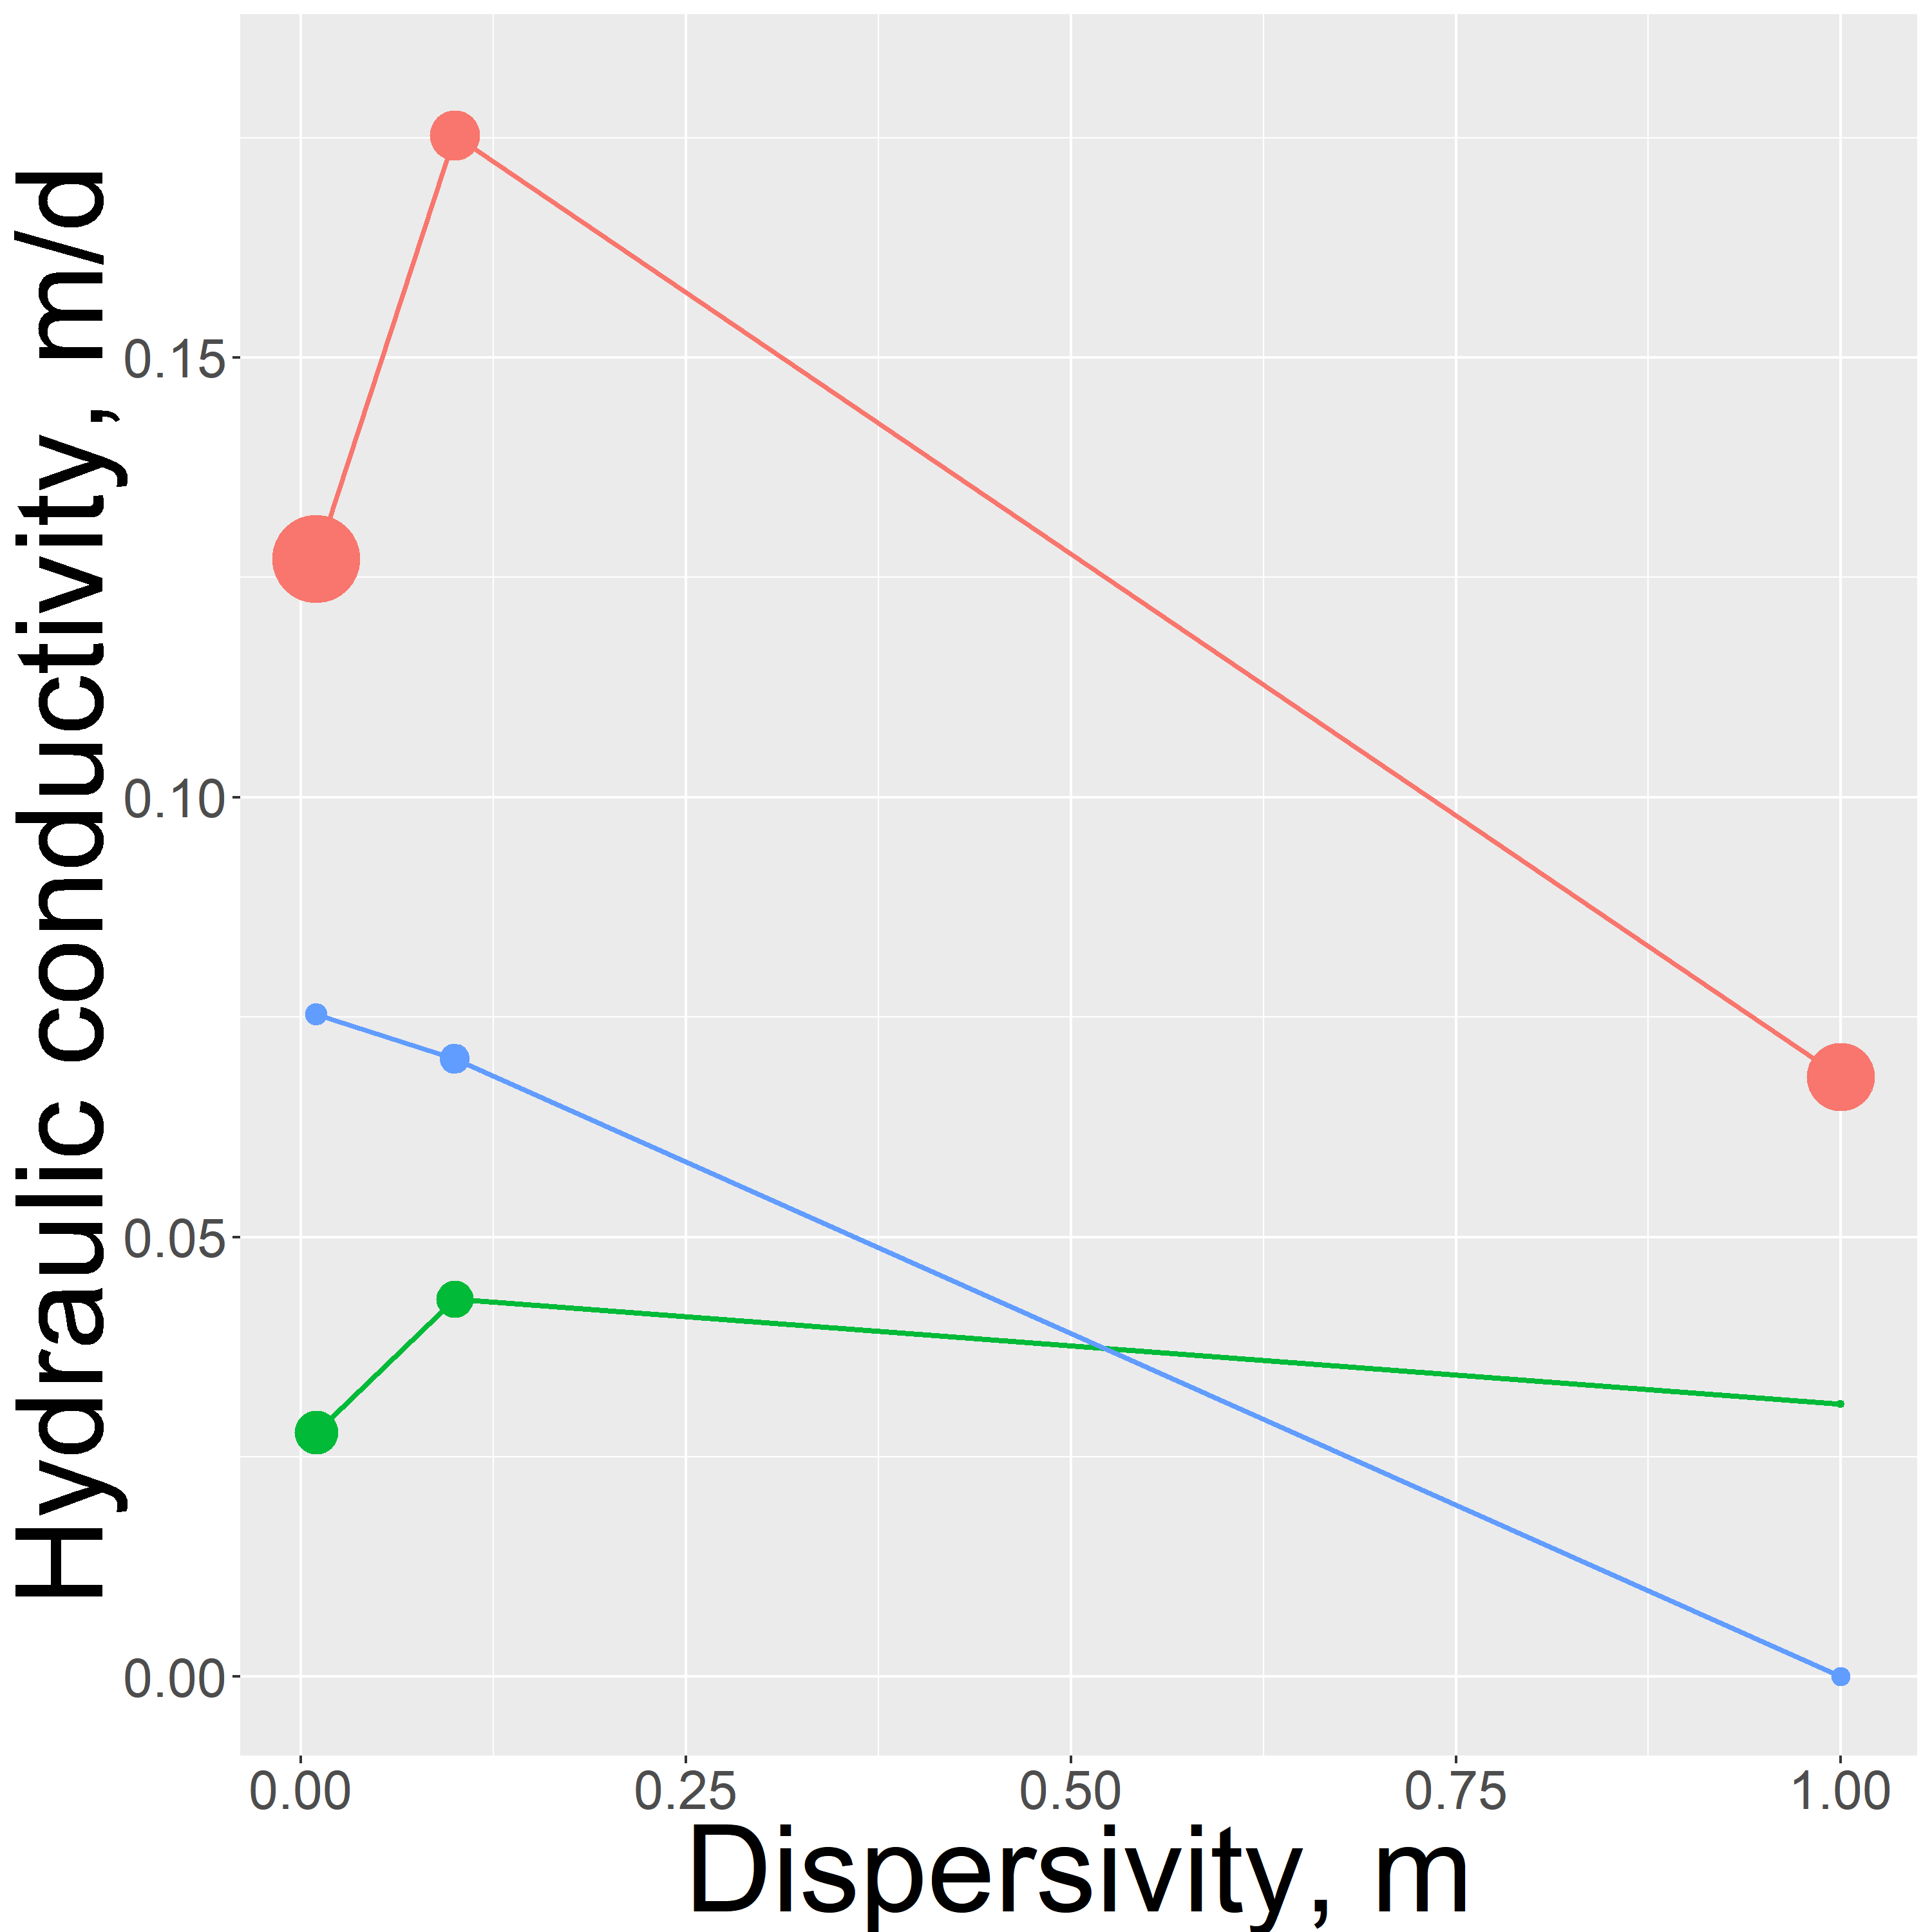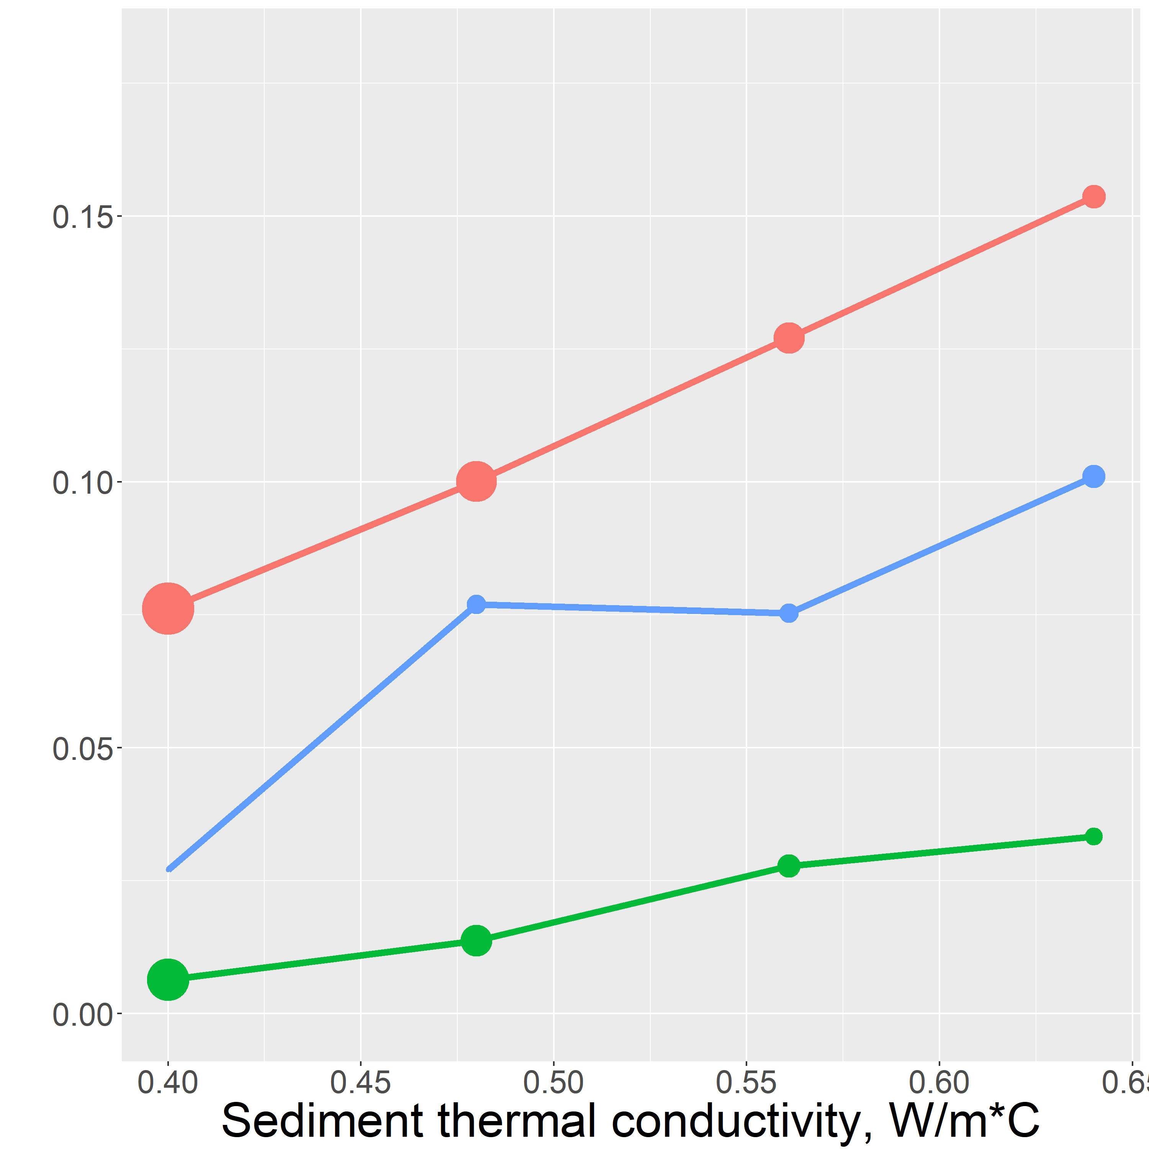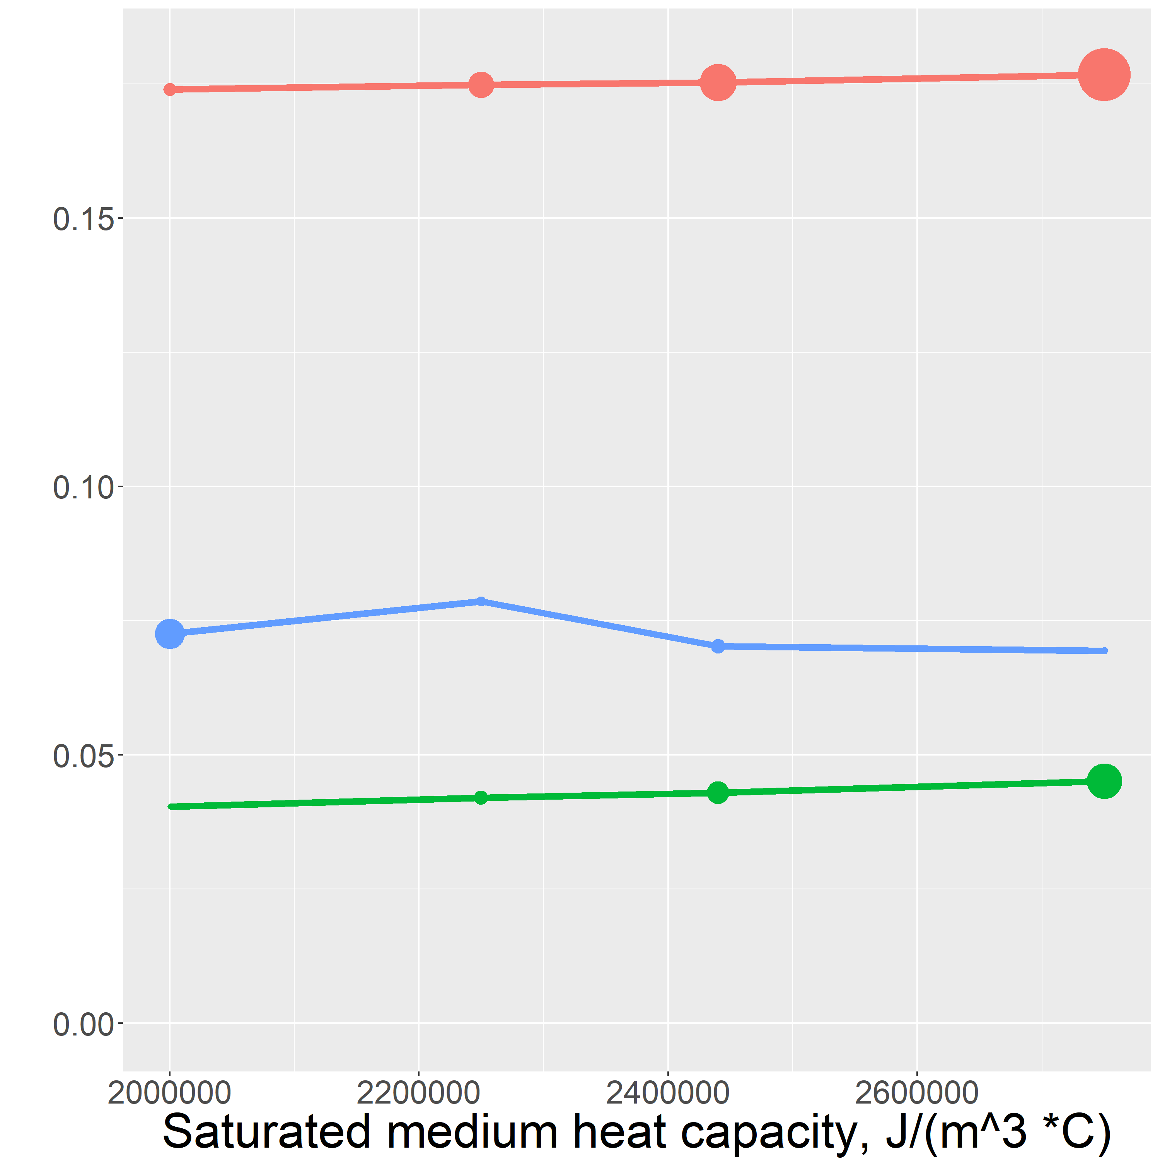

Model failure

Figure 4: Inverse model sensitivity analysis results. The sensitivity of each hand estimated parameter was tested by running the inverse model over a range of input values and comparing the results.

**Dispersivity sensitivity**

The inverse model sensitivity results show the strongest nonlinearity in the sensitivity to dispersity. This nonlinearity can be explained caused by the complicated interdependence of dispersity and flux magnitude. In Equation \_\_ the term that represents the transport of heat by dispersion is

This term shows that the effect of dispersion grows both as flow velocity grows and as the dispersivity, α, grows. Noting that depends linearly on, reasoning suggests that there is an inverse relationship between the dispersivity parameter value and the estimated value of . This relationship appeared in the sensitivity results above, however there appears to be additional phenomoenon occurring at middling dispersity values which these data are not enough to fully illuminate. An interested reader is referred to (Rau et al., 2012) for further investigation of the significance of thermal dispersion.

The value of the dispersivity also depends on the spatial scale that heat transport is taking place. (Zheng & Bennett, 2002). (Zheng & Bennet, 2002) state that at investigations of this scale, dispersivity generally varies between 0.01m and 1m. In this range, α = 0.1m gave the best quality of fit between the synthetic temperature profiles and the observed profiles so this value was chosen to be the representative vertical dispersivity at the site.

**Thermal conductivity**

The dependency of the inverse model results on thermal conductivity is fairly linear. This makes sense at our site because there is primarily upwards hydrologic flux. As thermal conductivity increases the diurnal surface water signal can propagate further into the streambed. To match the observed temperature profile, upwards hydrologic flux must increase and damped the diurnal signal. Increased upwards flux results in an increase in the estimated hydraulic conductivity.

The thermal conductivity value 0.56 W/(m C ) was chosen as the representative thermal conductivity of the sediment at the site. This value was chosen because it gave a good fit for all three temperature probes and, being in the middle of the range of possible values, helped average out heterogeneity at the site.

**Saturated heat capacity**

The inverse model results appear to have no dependence on saturated heat capacity. The saturated heat capacity value that was chosen to be the representative value for the site was

2.44 x 10^6 J/(m3 C). The lack of sensitivity to this parameter gives us confidence in choosing this as the representative value.

**Outro**

To summarize our findings, hydrologic flux at the site during the summer of 2016 was consistently upwards with variation in magnitude driven by precipitation. The results of this work have been used with reactive transport modeling to investigate the influence of hyporheic flux on biogeochemical cycling at Second Creek (Ng el al., 2017 (b)).

The results of this investigation could be expanded and improved by doing unique sediment parameter calibration for each temperature probe. This includes porosity and sediment content as well as thermal parameters. This could be achieved by careful sediment sampling and analysis in the field or by employing a multiple parameter estimation routine. This work would help quantify heterogeneity at the site and identify potential biogeochemical hot-spots.

**Appendix 1**

|  |  |
| --- | --- |
| **Symbol** | **Variable** |
|  | Hydraulic conductivity |
| φ | Porosity |
|  | Saturated thermal conductivity |
|  | Sediment heat capacity |
|  | Heat capacity of water |
| α | Dispersivity |
|  | Hyporheic flux |
|  | Temperature |

**References**

1. Farouki, Omar T. *Thermal Properties of Soils*. Tans Tech, 1986.
2. Hayashi, M. & Rosenberry, D.O., 2002. Effects of Ground Water Exchange on the Hydrology and Ecology of Surface Water. *Groundwater*, 40(3), pp.306–316.
3. Healy, R.W. & Ronan, A.D., 1996. Documentation of computer program VS2DH for simulation of energy transport in variably saturated porous media -- modification of the U.S. Geological Survey’s computer program VS2DT. Water-Resources Invenstigations Report 96-4230. *U.S. Geological Survey*.
4. Koch, F.W., Voytek, E.B., Day-Lewis, F.D., Healy, R., Briggs, M.A., Werkema, D., and Lane, J.W., Jr., 2015, 1DTempPro V2: New Features for Inferring Groundwater/Surface-Water Exchange, Groundwater, doi:10.1111/gwat.12369, 6p.
5. Koch, F.W., Voytek, E.B., Day-Lewis, F.D., Healy, R., Briggs, M.A., Werkema, D., and Lane, J.W., Jr., 2015, 1DTempPro: A program for analysis of vertical one-dimensional (1D) temperature profiles v2.0: U.S. Geological Survey Software Release, 23 July 2015, http://dx.doi.org/10.5066/F76T0JQS.
6. Kurtz, A.M. et al., 2007. The importance of subsurface geology for water source and vegetation communities in Cherokee Marsh, Wisconsin. *Wetlands*, 27(1), pp.189–202.
7. Myrbo, A., 2013. Wild Rice Sulfate Standard Field Surveys 2011, 2012, 2013: Final Report. , Submitted to the Minnesota Pollution Control Agency, St. Paul, Minn. *University of Minnesota*.;
8. Ng G.-H. C., A.R. Yourd, N.W. Jonson, A.E. Myrbo., 2017, (a) Modelling hydrologic controls on sulfur processes in sulfate-impacted wetland and stream sediments. *Journal of Geophysical Research: Biogeosciences,* , volume 122, issues 9, 21 August 2017, https://doi.org/10.1002/2017JG003822
9. Ng G.-H. C., O’Hara, P., Santelli, C., Rosenfeld, C., Yourd, A., 2017,  (b) Evaluating the role of sulfur and hyporheic exchange in biogeochemical cycling in riparian wetlands, Abstract H12E-05 presented at 2017 Fall Meeting, AGU, New Orleans, Calif., 11-15 Dec.
10. Pastor, J. et al., 2017. Effects of sulfate and sulfide on the life cycle of Zizania palustris in hydroponic and mesocosm experiments. *Ecological Applications*, 27(1), pp.321–336.
11. Rau, G., Andersen, M., Acworth, R. Experimental investigation of the thermal dispersivity term and its significance in the heat transport equation for flow in sediments.  *Water Resources Research,*  48, W03511, doi: 10.1029/2011WR011038
12. Voytek, E.B.; Drenkelfuss, Anja; Day-Lewis, F.D.; Healy, Richard; Lane, J.W., Jr.; and Werkema, Dale, 2013, 1DTempPro: Analyzing Temperature Profiles for Groundwater/Surface-water Exchange: *Ground Water*.
13. Wickert, A 2014.The Alog: inexpensive, Open Source, Automated Data Collection in the Field.  *The Bulletin of the Ecological Society of America,*April 2014, <https://doi.org/10.1890/0012-9623-95.2.68>
14. Yourd, A., 2017**.** *Using reactive transport modeling to link hydrologic flux and root zone geochemistry at Second Creek, a sulfate enriched wild rice stream in northeastern Minnesota, Masters Thesis, University of Minnesota*.;
15. Zheng, Chunmiao, and Gordon D. Bennett. “Applied Contaminant Transport Modeling, 2nd Edition.” *Wiley.com*, 5 Feb. 2002, www.wiley.com/WileyCDA/WileyTitle/productCd-0471384771.html.